|  |  |
| --- | --- |
| Course Name | ITD 2313 – Script Programming |
| Instructor | Put instruction name here |
| Student Name | Put student name here |
| Due date | Put assignment due date here |
| Grade | Put grade earned here |
| Grading Comments | Put instructor comments here |

### Page 78

1. At the top of the page, you will find a code example block with several boolean expressions to enter
2. About 3/4 the way down on the page, you will find a code example block starting with import math.  This is the final code example block on the page.
3. You do not type in the if template as part of this exercise.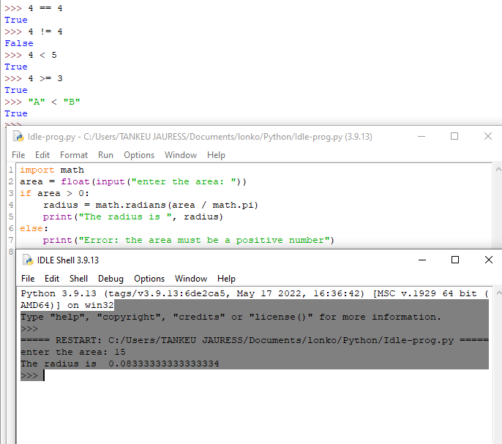

## if-else statements

### Page79

1. At the half way point is your first code example block for this page
2. The second and final for the page hits at about the 2/3 mark on the page and covers min/max functionality.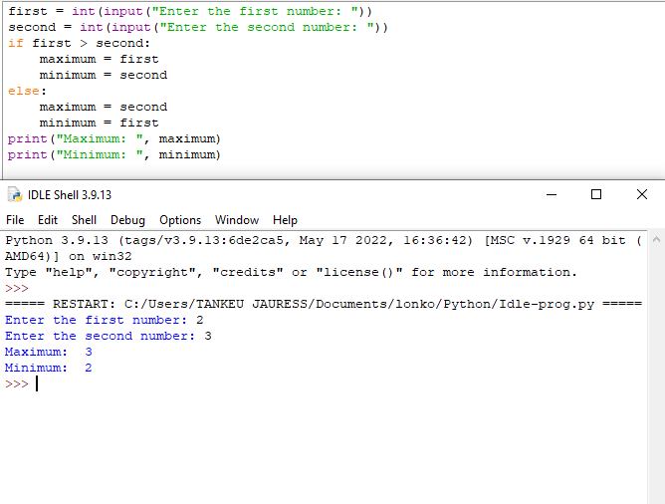

## Multi-way if statements

### Page 81

1. The first of the 2 code example blocks is near the top of the page.
2. The second code example block is in the middle of the page.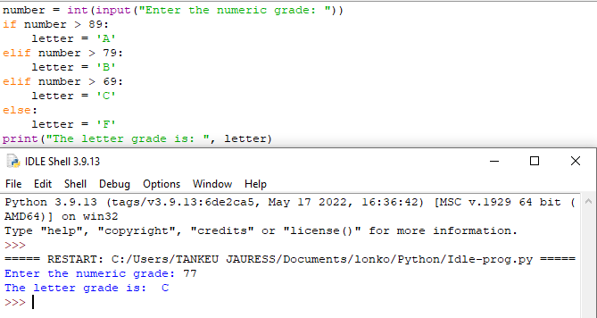

## Logical Operators and Compound boolean expressions

### Page 82

1. The code example block is about 1/4 the way down on the page.
2. The second code example block is about 1/2 way down.  Notice in this example that there is a single line comment saying that the compute and print code goes here.  I would like you to replace that comment with the code the computers the Square of the number they input and prints out the result to the user.
3. The third code example block is about 2/3 the way down the page.  It also has a single line comment that will need to be replaced with code the computes and displays the square of the number input.
4. Steps 2 and 3 show code but not any results in the text.  You will need to execute the code so that it shows the results on both sides of the if statement.  This will mean 2 screen shots for each step.  One shows the true and one shows the false.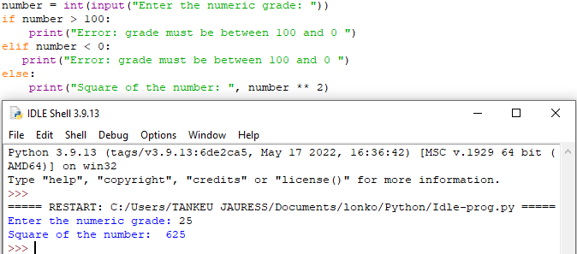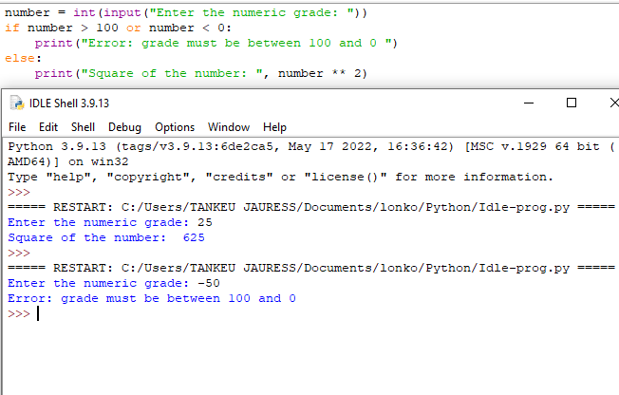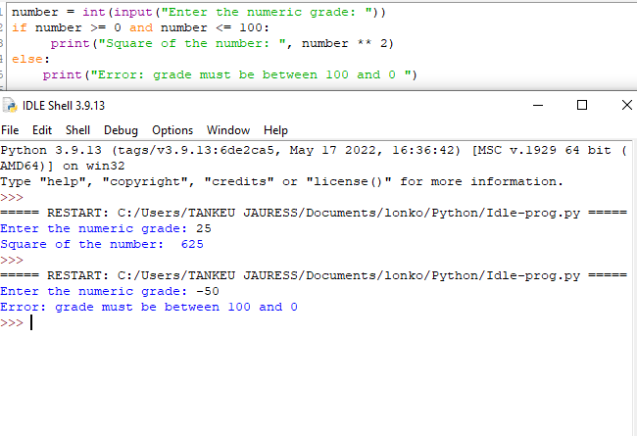

### Page 83

1. The first code example block on the page is at the 1/2 way point on the page.
2. The 2nd and final code example block is on the bottom of the page.  It does not spill onto the next page.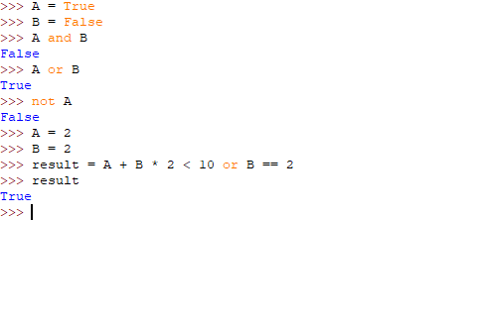

## Short Circuit evalution

### Page 84

1. The first code example block is about 2/3 the way down the page.  Show how it runs with a couple of different values.  Count needs to be set to 0 at least 1 time.
2. For a better understanding of the topic, consider for your own learning to switch the order of the two items in the compound boolean expression.  That means, check the count>0 on the Right Side of the AND.  See what happens when you run it with Count = 0.  This is just for you to further understand and see the results.  You will not need to screen shot this step.